Marketing Research

Portable Fans
1. Aecooly Mighty Portable Fan
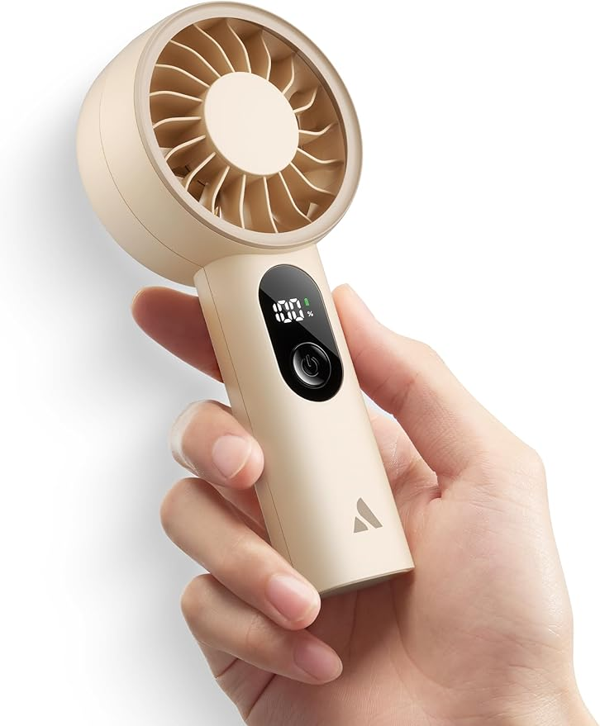

Aecooly Mighty Portable Fan, Powerful Handheld Fan, USB Rechargeable [10H Max Cooling Time], Mini Personal Battery Powered, Pocket for Travel, Summer, Gifts for Women, Girls -Beige
Battery Powered
4.8 out of 5 stars
(360)
6K+ bought in past month
Price, product pageLKR3,275.22 Typical: LKR 3,643.18
Typical: LKR3,643.18
Features & Specs
Power Source | Battery Powered
Room Type | Bedroom, Office, Outdoor
Special Features | Mighty Portable Fan with 5-Speed
Recommended Uses For Product | Cooling
Mounting Type | Handheld
Controller Type | Button Control
Number of Speeds | 5
Noise Level | 50 Decibels
Wattage | 3 watts
Number of Blades | 7
Switch Type | Push Button
Indoor Outdoor Usage | Indoor, Outdoor
Control Method | Push Button
Reusability | Rechargeable
Is Product Cordless | Yes
Number of Power Levels | 5
Main Power Connector Type | USB Type C
Smart Home Compatibility | Not Smart Home Compatible
Installation Type | Handheld
product link

- Everlasting Comfort Portable Handheld Fan
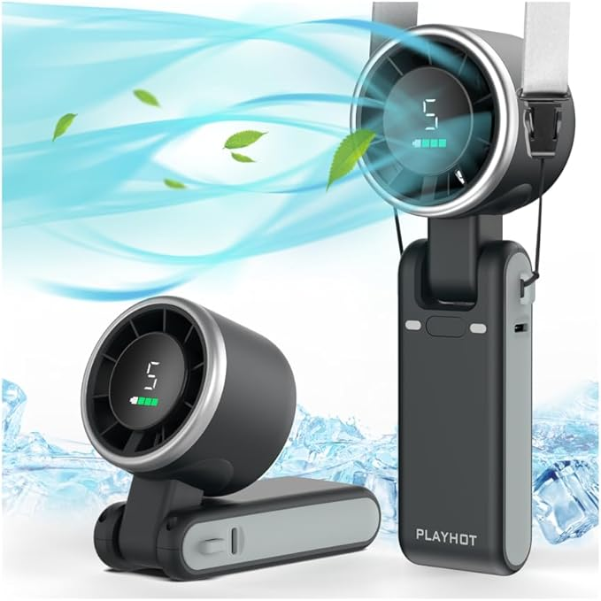

Everlasting Comfort Portable Handheld Fan, Rechargeable with LED Display & Cooling Mode, Small Personal Mini Portable Fan, 5 Speeds for Outdoor Travel, Hiking, Makeup, Camping, Office, Gifts for Women
Battery Powered
Top Brand
4.7 out of 5 stars
(34)
New on Amazon in past month
Price, product pageLKR4,637.68
Features & Specs
Power Source | Battery Powered
Room Type | Anywhere, Bedroom, Kids Room, Living Room, Playroom
Special Features | Adjustable Height, Adjustable Tilt, Foldable, Lightweight, Portable
Recommended Uses For Product | Air Circulation, Cooling, Drying
Mounting Type | No Assembly
Controller Type | Button Control
Number of Speeds | 5
Noise Level | 75 Decibels
Wattage | 5 watts
Number of Blades | 6
Speed | 13550 RPM
Voltage | 5 Volts
Switch Type | Push Button
Indoor Outdoor Usage | Indoor, Outdoor
Control Method | Touch
Reusability | Rechargeable
Is Product Cordless | Yes
Number of Power Levels | 5
Main Power Connector Type | USB Type C
Motor Type | brushless
Smart Home Compatibility | Not Smart Home Compatible
Installation Type | portable
Connector Type | USB Type C
Is Electric | Yes

product link
3. JISULIFE 3 IN 1 Handheld Mini Fan

JISULIFE 3 IN 1 Handheld Mini Fan - Portable Fan & Power Bank & Flashlight, 19H Max Cooling, USB Rechargeable, Pocket-Sized for Travel, Cruise, Concerts, Makeup, 2026 Summer Gifts for Women (Pink)
Battery Powered
1 Count (Pack of 1)
4.64.6 out of 5 stars
(76.7K)
10K+ bought in past month
Price, product pageLKR4,561.44 (LKR4,561.44/count)
Power Source | Battery Powered
Room Type | Office
Special Features | 3 IN 1 Pocket Fan with Flashlight and Power Bank Function
Recommended Uses For Product | Cooling
Mounting Type | Handheld
Controller Type | Button Control
Number of Speeds | 2
Noise Level | 60 Decibels
Wattage | 4 watts
Number of Blades | 2
Speed | 2 RPM
Voltage | 5 Volts
Switch Type | Push Button
Indoor Outdoor Usage | Outdoor
Control Method | Touch
Reusability | Rechargeable
Is Product Cordless | No
Number of Power Levels | 2
Main Power Connector Type | USB
Smart Home Compatibility | Not Smart Home Compatible
Installation Type | Portable
Connector Type | USB Type C
Light Type | LED
product link

4. JISULIFE 3 IN 1 Handheld Mini Fan

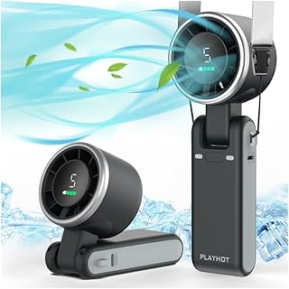

JISULIFE 3 IN 1 Handheld Mini Fan, 5 Gear Wind, USB-C Rechargeable Fan, Up to 12 Working Hours, 3 IN 1 Hand Fans with Air Turbo Tech Cooling Fan for Outdoor Activities, Travel, Beach (Black)

Battery Powered
4.64.6 out of 5 stars
(8.7K)
9K+ bought in past month
Price, product pageLKR5,628.87 List: LKR 6,626.68
List: LKR6,626.68
Features & Specs
Power Source | Battery Powered
Room Type | Anywhere, Bedroom, Kids Room, Living Room, Playroom
Special Features | Adjustable Height, Adjustable Tilt, Foldable, Lightweight, Portable
Recommended Uses For Product | Air Circulation, Cooling, Drying
Mounting Type | No Assembly
Controller Type | Button Control
Number of Speeds | 5
Noise Level | 75 Decibels
Wattage | 5 watts
Number of Blades | 6
Speed | 13550 RPM
Voltage | 5 Volts
Switch Type | Push Button
Indoor Outdoor Usage | Indoor, Outdoor
Control Method | Touch
Reusability | Rechargeable
Is Product Cordless | Yes
Number of Power Levels | 5
Main Power Connector Type | USB Type C
Motor Type | brushless
Smart Home Compatibility | Not Smart Home Compatible
Installation Type | portable
Connector Type | USB Type C
Is Electric | Yes

link
5. Portable Handheld Turbo Fan
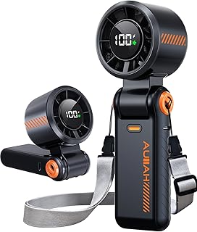

Portable Handheld Turbo Fan - 5 Speed Mini Personal Fan with Strong Airflow, Foldable 3 in 1 Rechargeable Battery Operated Travel Essentials Hand Fans for Indoor/Outdoor Use, Black
Battery Powered
4.94.9 out of 5 stars
(203)
2K+ bought in past month
Price, product pageLKR4,306.18 List: LKR 8,284.18
List: LKR8,284.18
Features & Specs
Power Source | Battery Powered
Room Type | Bedroom, Home, Kitchen, Living Room, Room
Special Features | 5-Speed Adjustment, Foldable, Lightweight, Portable, With LED Display
Recommended Uses For Product | Cooling
Mounting Type | Free Standing
Number of Speeds | 5
Wattage | 5 watts
Indoor Outdoor Usage | Outdoor
Control Method | Push Button
Is Product Cordless | Yes
Number of Power Levels | 5
Motor Type | Brushless
Smart Home Compatibility | Not Smart Home Compatible
Installation Type | Portable

Product link

6. JISULIFE Handheld Fan Pro1 Mini - Scented Breeze

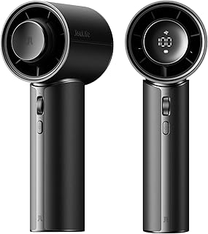

JISULIFE Handheld Fan Pro1 Mini - Scented Breeze: Elite PU Leather, Aroma Pod Innovation, 30 Hours Cooling, 100-Speed, Portable Fan for Travel, Concerts, Premium Gifts for Women Men- Velvet Black​
Battery Powered
4.64.6 out of 5 stars
(40)
100+ bought in past month
Price, product pageLKR19,886.68
Features & Specs
Power Source | Battery Powered
Room Type | Standard room
Special Features | Manual
Recommended Uses For Product | Indoor/Outdoor
Mounting Type | Free Standing
Number of Speeds | 100
Noise Level | 45 Decibels
Wattage | 4.25 watts
Number of Blades | 5
Speed | 17000 RPM
Indoor Outdoor Usage | Indoor, Outdoor
Control Method | Touch
Is Product Cordless | Yes
Number of Power Levels | 100
Motor Type | Brushless
Smart Home Compatibility | Not Smart Home Compatible
Installation Type | No Installation Required

7. JISULIFE Portable Handheld Fan Life9
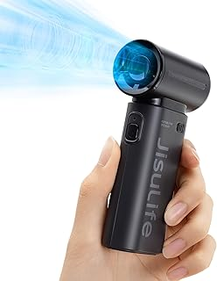

JISULIFE Portable Handheld Fan Life9, Turbo Power High Speed Air [18H Max Cooling Time], 5 Gear Wind, 5000mAh Rechargeable, Mini Pocket Design, Personal Fan for Travel Concerts Camping Makeup - Black
Battery Powered
4.6 out of 5 stars
(3.2K)
1K+ bought in past month

Features & Specs
Power Source | Battery Powered
Room Type | Standard room
Special Features | Manual
Recommended Uses For Product | Indoor/Outdoor
Mounting Type | Free Standing
Controller Type | Touchpad Control
Number of Speeds | 5
Noise Level | 74 Decibels
Wattage | 6 watts
Number of Blades | 9
Speed | 40000 RPM
Voltage | 230 Volts
Switch Type | Push Button
Indoor Outdoor Usage | Indoor, Outdoor
Control Method | Touch
Reusability | Rechargeable
Standby Power Shutoff | High
Is Product Cordless | Yes
Number of Power Levels | 5
Motor Type | brushless DC motor
Smart Home Compatibility | Not Smart Home Compatible
Installation Type | No Installation Required
Connector Type | USB Type C
Is Electric | Yes

Product link
8. Portable Handheld Turbo Fan for Outdoor

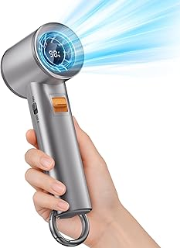

Portable Handheld Turbo Fan for Outdoor - 5000mah Mini Handheld Personal Pocket Fan for Powerful Airflow Wind - 20hrs,100 Speeds Adjustable - Digital Display,Gifts for Travel,Outdoor Activites,Camping
Battery Powered
4.74.7 out of 5 stars
(759)
300+ bought in past month
Price, product pageLKR7,289.68 List: LKR 9,278.68
List: LKR9,278.68
Features & Specs
Power Source | Battery Powered
Room Type | home, indoor, office, outdoor
Special Features | Bladeless, Handheld, Lightweight, Portable
Recommended Uses For Product | Cooling, handheld, put on desk
Mounting Type | handheld
Controller Type | Button Control
Number of Speeds | 100
Noise Level | 50 Decibels
Wattage | 5.29 watts
Number of Blades | 6
Speed | 12000 RPM
Voltage | 5 Volts
Switch Type | Push Button
Indoor Outdoor Usage | Indoor, Outdoor
Control Method | Touch
Reusability | Rechargeable
Is Product Cordless | Yes
Number of Power Levels | 100
Motor Type | Brushless
Smart Home Compatibility | Not Smart Home Compatible
Installation Type | Handheld

product link
9. JISULIFE Handheld Portable Turbo Fan
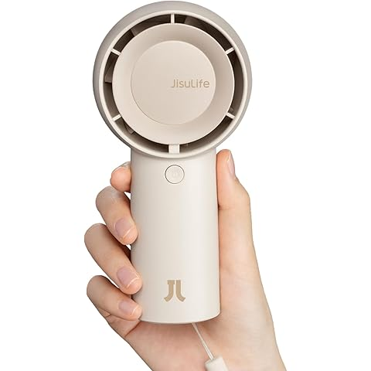

JISULIFE Handheld Portable Turbo Fan [16H Max Cooling Time], 4000mAh USB Rechargeable Personal Battery Operated Mini Small Pocket Fan with 5 Speeds for Travel/Outdoor/Vacation/Concerts - Brown
Visit the JISULIFE Store
4.7 4.7 out of 5 stars (9,090)azhoice
4K+ bought in past month
LKR 5,831.08 with 20 percent savings-20% LKR5,831.08
Features & Specs
Power Source | Battery Powered
Room Type | Bathroom, Bedroom, Home Office
Special Features | 5 Speeds Turbo Air Duct, Turbo Design
Recommended Uses For Product | Air Circulation
Mounting Type | Free Standing,handheld
Controller Type | Touchpad Control
Number of Speeds | 5
Noise Level | 40 Decibels
Wattage | 5 watts
Number of Blades | 7
Air Flow Capacity | 600 Centiliters Per Second
Speed | 6100 RPM
Voltage | 5 Volts
Switch Type | Push Button
Indoor Outdoor Usage | Indoor, Outdoor
Control Method | Touch
Reusability | Rechargeable
Standby Power Shutoff | High
Is Product Cordless | Yes
Number of Power Levels | 5
Motor Type | Brushless
Smart Home Compatibility | Not Smart Home Compatible
Installation Type | Portable
Connector Type | USB Type C
Is Electric | Yes

product link

10. Portable Handheld Turbo Fan

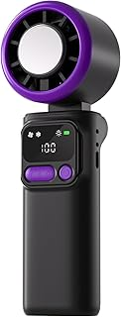

Portable Handheld Turbo Fan, 3 IN 1 Hand Fan with Air Turbo Tech Ice Cooler, LED Light, 4000mAh Rechargeable Battery Operated Cooling Fan for Outdoor Activities, Travel, Working, Beach,Women Men
hand_powered
4.74.7 out of 5 stars
(39)
Price, product pageLKR29,831.68
Features & Specs
Power Source | hand_powered
Room Type | NO
Special Features | Portable
Recommended Uses For Product | Handheld fan
Mounting Type | NO
product link

Portable Fan Comparison Summary
Rank | Product | Price (LKR) | Rating | Bought/Month | Max Runtime | Speeds | Noise | Battery | Key Features | Overall Verdict
🥇 1 | JISULIFE Life9 | N/A | 4.6★ (3.2K) | 1K+ | 18H | 5 | 74dB | 5000mAh | 40,000 RPM Turbo Power | Best Performance
🥈 2 | JISULIFE Turbo Fan 4000mAh | 5,831 | 4.7★ (9K) | 4K+ | 16H | 5 | 40dB | 4000mAh | Quiet + Turbo Design | Best Overall Balance
🥉 3 | Aecooly Mighty | 3,275 | 4.8★ (360) | 6K+ | 10H | 5 | 50dB | N/A | Excellent value | Best Budget Choice
4 | JISULIFE 3-in-1 (Pink) | 4,561 | 4.6★ (76K) | 10K+ | 19H | 2 | 60dB | N/A | Fan + Power Bank + Flashlight | Best Multi-Function
5 | Portable Turbo Fan (100 Speed) | 7,290 | 4.7★ (759) | 300+ | 20H | 100 | 50dB | 5000mAh | Digital Display | Best Premium Features
6 | Portable Handheld Turbo Fan | 4,306 | 4.9★ (203) | 2K+ | N/A | 5 | N/A | N/A | Foldable + LED Display | Best Rating
7 | Everlasting Comfort | 4,638 | 4.7★ (34) | New | N/A | 5 | 75dB | N/A | LED Display | Good Alternative
8 | JISULIFE 3-in-1 Air Turbo | 5,629 | 4.6★ (8.7K) | 9K+ | 12H | 5 | 75dB | N/A | Air Turbo Technology | Strong Airflow
9 | JISULIFE Pro1 Mini | 19,887 | 4.6★ (40) | 100+ | 30H | 100 | 45dB | N/A | Aroma Pod + Premium Build | Luxury Option
10 | Portable Turbo Fan Ice Cooler | 29,832 | 4.7★ (39) | N/A | N/A | N/A | N/A | 4000mAh | LED Light + Ice Cooling | Overpriced

Category Winners
Category | Winner
Best Overall | JISULIFE Turbo Fan 4000mAh (No. 9)
Best Budget | Aecooly Mighty
Most Powerful Airflow | JISULIFE Life9 (40,000 RPM)
Longest Battery Life | JISULIFE Pro1 Mini (30 Hours)
Quietest Fan | JISULIFE Turbo Fan 4000mAh (40dB)
Most Features | Portable Turbo Fan (100 Speed, 5000mAh)
Best for Travel | JISULIFE 3-in-1 Pocket Fan
Best Gift Product | JISULIFE Pro1 Mini
Best Value for Money | Aecooly Mighty
Highest Consumer Trust | JISULIFE 3-in-1 Pocket Fan (76.7K Reviews)

Value-for-Money Score (10-point scale)
Product | Score
Aecooly Mighty | 9.5/10
JISULIFE Turbo Fan 4000mAh | 9.4/10
JISULIFE Life9 | 9.2/10
JISULIFE 3-in-1 Pocket Fan | 9.0/10
Portable Turbo Fan (100 Speed) | 8.8/10
Portable Handheld Turbo Fan | 8.7/10
Everlasting Comfort | 8.3/10
JISULIFE Air Turbo | 8.2/10
JISULIFE Pro1 Mini | 7.5/10
Portable Turbo Fan Ice Cooler | 5.0/10

